WK2-PM3-FOOTPRINTING WITH MALTEGO

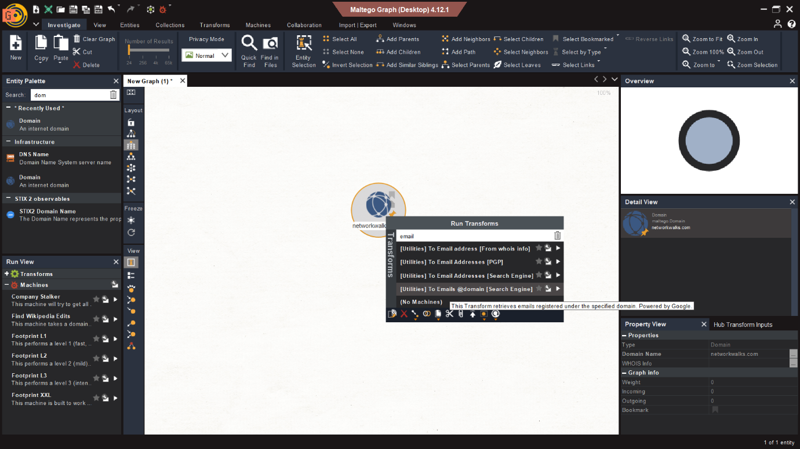

- Footprinting was performed using Maltego to gather publicly available information about the target domain.
- Different transforms were used to identify related email addresses and other entities.
- The collected information was represented as a visual relationship graph.
- This helped in understanding the target’s digital footprint.

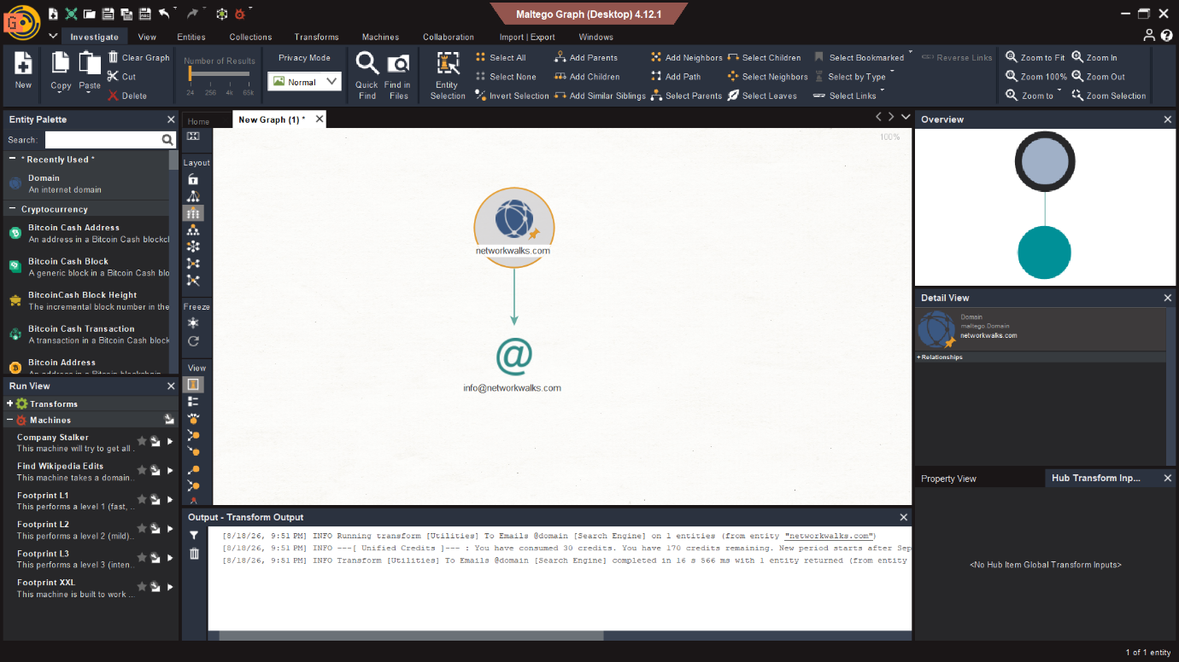
- In this step, the domain was transformed into an email address using Maltego.
- The transform searched publicly available sources for email information related to the domain.
- The discovered email was then displayed as a connected entity in the graph.
- This demonstrates OSINT-based footprinting using Maltego..

